Student Name | ID- 22081679

Aavash Sapkota

Module Leader: Dr Bilal Hassan

Submission Date: 11/12/25



Simulation of a Smart Home Network using Cisco Packet Tracer

Cloud Computing and the Internet of Things

Assignment no: 001, 2025-26

CS5053

Table of contents:

Contents

Table of contents: 2

1. Introduction 3

2. Network Architecture and Component Design 3

2.1. Network Infrastructure 3

2.2. Wireless IoT devices setup 4

2.3. MCU- controlled sensors 6

3. Implementation of Automation Scenarios 8

3.1 Remote Appliance Control 8

3.2 Water Level Monitoring and LCD Automation 10

3.3 Wind Turbine Energy Generation 11

3.4 CO Threshold Detection and Garage Automation 13

3.5 Humidity Monitoring and Environmental Feedback 14

3.6 Trip Sensor and Security Response 15

3.7 Thermostat Heating and Cooling Control 17

4. Critical Reflection and things learned. 18

5. Conclusion and Social Impact 20

6. References 21

7.Appendix: Project Logbook 22

1. Introduction

This report outlines the concept, design, and configuration. In addition, this report reflects the testing and results of the simulation of the smart home, which was entirely conducted within Cisco Packet Tracer. **The project aimed to simulate the IoT environment, highlighting the features of a smart home, including automation, connectivity via wire and wireless, triggered reactions, and interactions between devices based on conditions.** Furthermore, this report correlates the modular learning from the CS5053 learnings with functionality, sensors, and context-aware decisions as per the given scenarios. The smart home Cisco system not only helps users to control individual IoT devices but also a series of smart devices and an ecosystem that communicates and coordinates with one another. This reflects the concept of “ubiquitous intelligence” described in IoT literature, where everyday environments adapt to user needs through embedded sensing and cloud-mediated control (Atzori et al., 2010).

The smart home simulation incorporates a variety of interconnected subsystems, such as microcontrollers (MCU), environmental sensors, a security system, a wind power system, and tests seven operational scenarios. These scenarios were very crucial to illustrating the functional and behavioural dynamics. Cisco (2023)

# 2. Network Architecture and Component Design

## 2.1. Network Infrastructure

The foundational network architecture consists of a router, switch, home gateway, registration server, and desktop PC connected through Fast Ethernet links. This hybrid approach mirrors real-world installations where wired infrastructure is prioritised for stability and wireless segments for flexibility (Buyya and Dastjerdi, 2016).

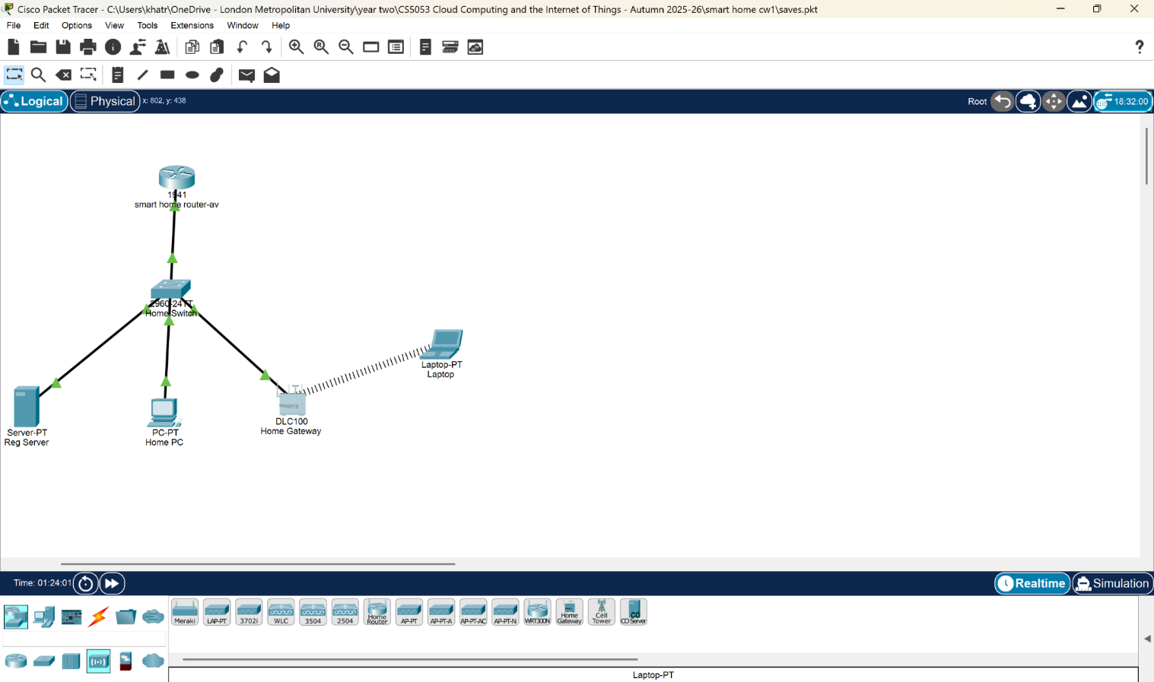

Fig 2.1. Foundation of the smart home system.

The home gateway is the central wireless controller to communicate with all the IoT devices. It gives out the IP address assignment via DHCP with IoT devices, which act as a middleman for the registration server. Correct gateway configuration helps to ensure reliable communication. For this report, the IP address is 192.168.10.2. This model reflects typical IoT gateway architectures described in industry standards, where local processing and protocol translation enhance system efficiency (Gubbi et al., 2013).

## 2.2. Wireless IoT devices setup

The wireless segment, this report has three devices (a laptop, smartphone, and my kid's tablet) for multiple users and controls different IoT appliances such as webcam, home speaker, light, coffee maker, ceiling fan, lawn sprinkler, 3 windows, garage door and front door and many more as shown in Figure 2.2.A.

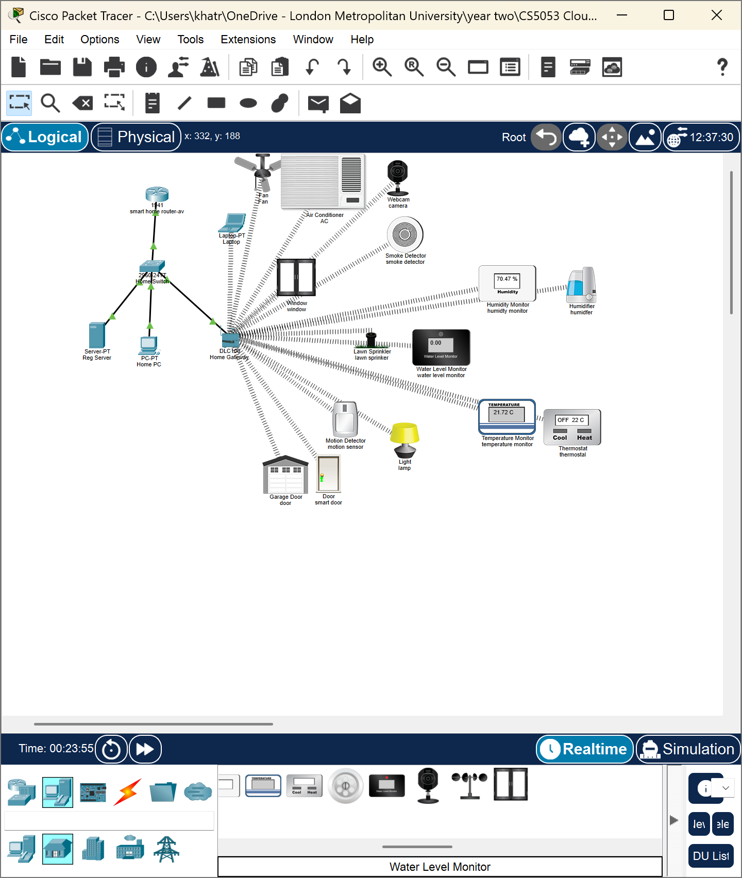

Fig 2.2.A. IoT device wireless connection setup

Integrating diverse wireless IoT devices demonstrates the concept of “heterogeneous device ecosystems,” where varying device classes coexist through shared communication channels (Sethi and Sarangi, 2017).

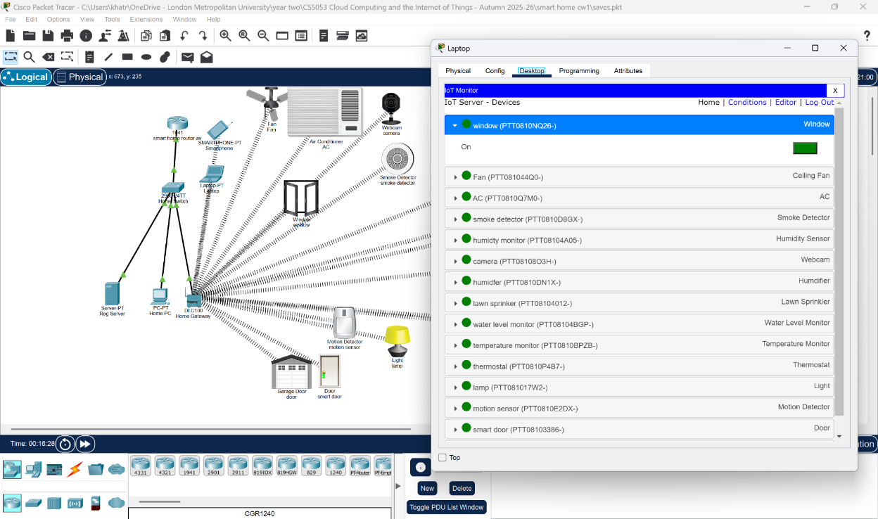

Fig 2.2.B. Controlling IoT devices through a laptop.

In practice, IoT devices are limited to bandwidth, energy supply and wireless protocols. Simulating these interactions gave insight into understanding complex inside and network reliability in dense IoT systems.

## 2.3. MCU- controlled sensors

A set of sensors and actuators was connected to the MCU boards, such as a smoke sensor, temperature sensor, LCD, alarm, siren, and trip sensor. Thus, testing is done before connecting to the real simulation. MCU programming introduced embedded decision logic, demonstrating edge computing principles where local processing reduces reliance on cloud communication (Xu, He and Li, 2014). However, later, as per the coursework, this project focused on the MCU for the water sensor only.

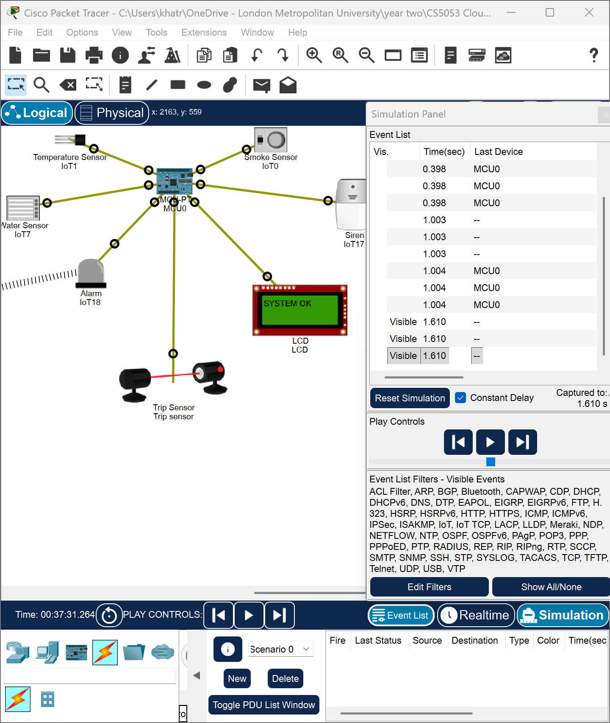

Fig 2.3. MCU setup and testing.

# 3. Implementation of Automation Scenarios

## 3.1 Remote Appliance Control

Every IoT device is controlled via smartphone, laptop and tablet. This scenario shows IoT orchestration. When device is exposed, its control is through unified dashboards. This concept is the foundation for this smart home system. (Chan et al., 2008).

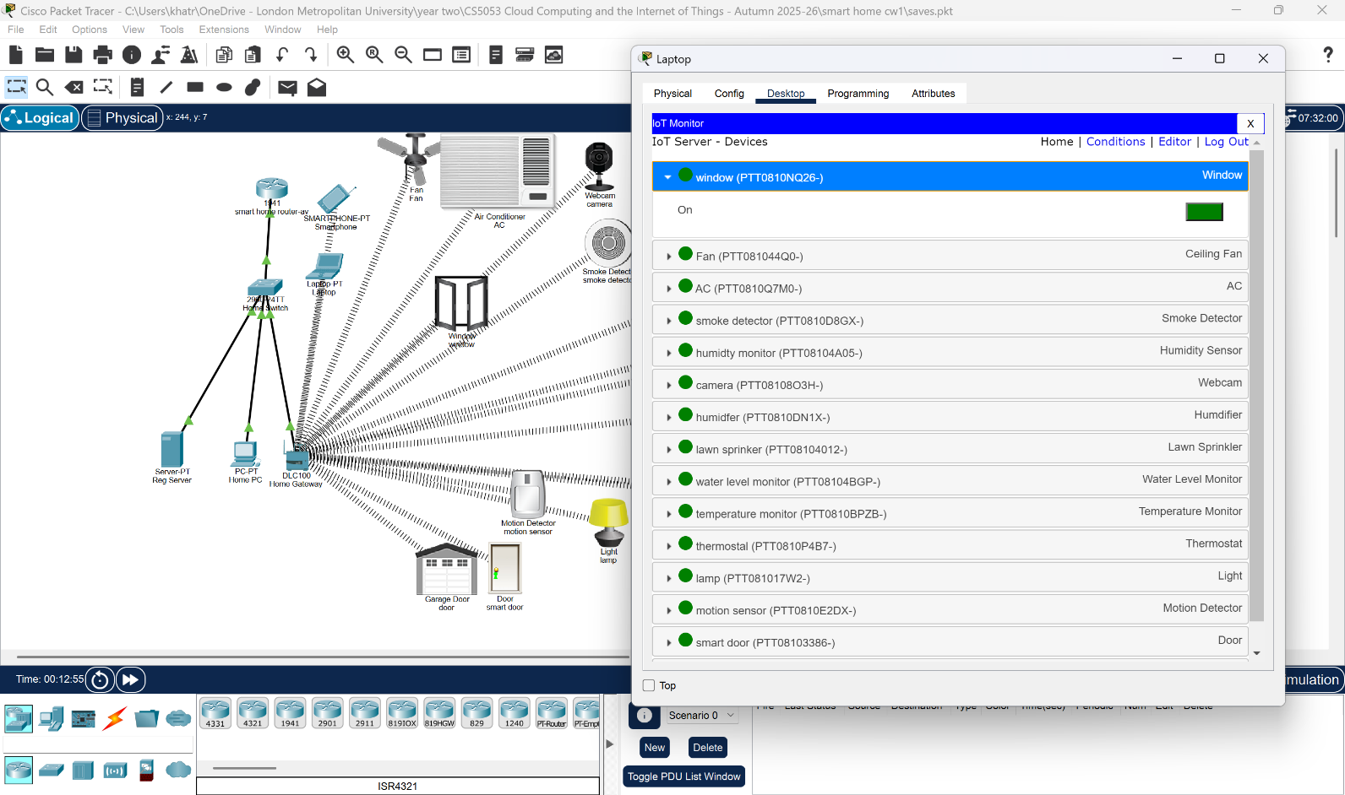

Fig 3.1.A. IoT monitoring

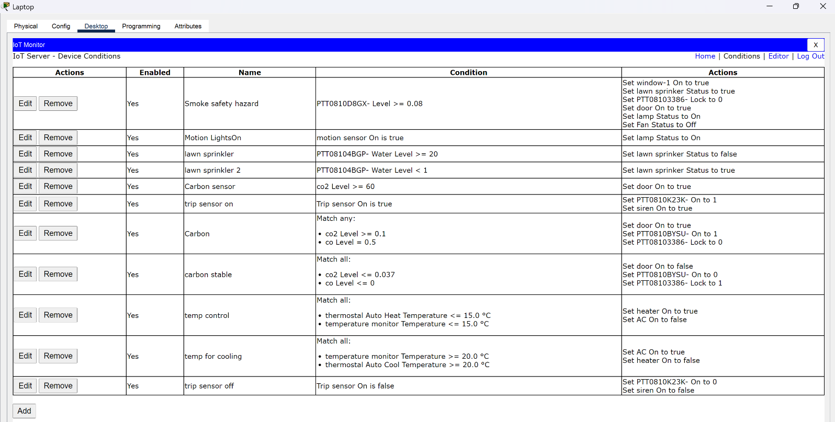

Fig 3.1.B. IoT devices conditions

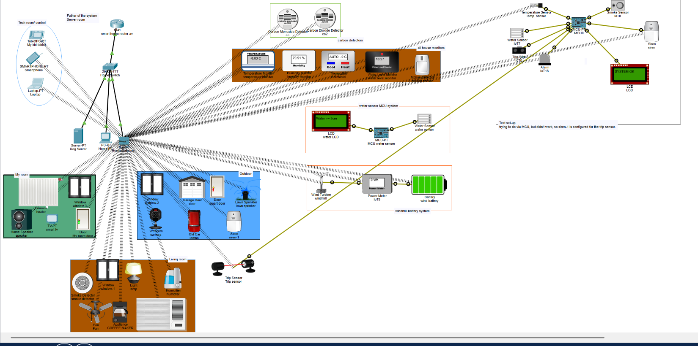

Fig 3.1.C Overall system

## 3.2 Water Level Monitoring and LCD Automation

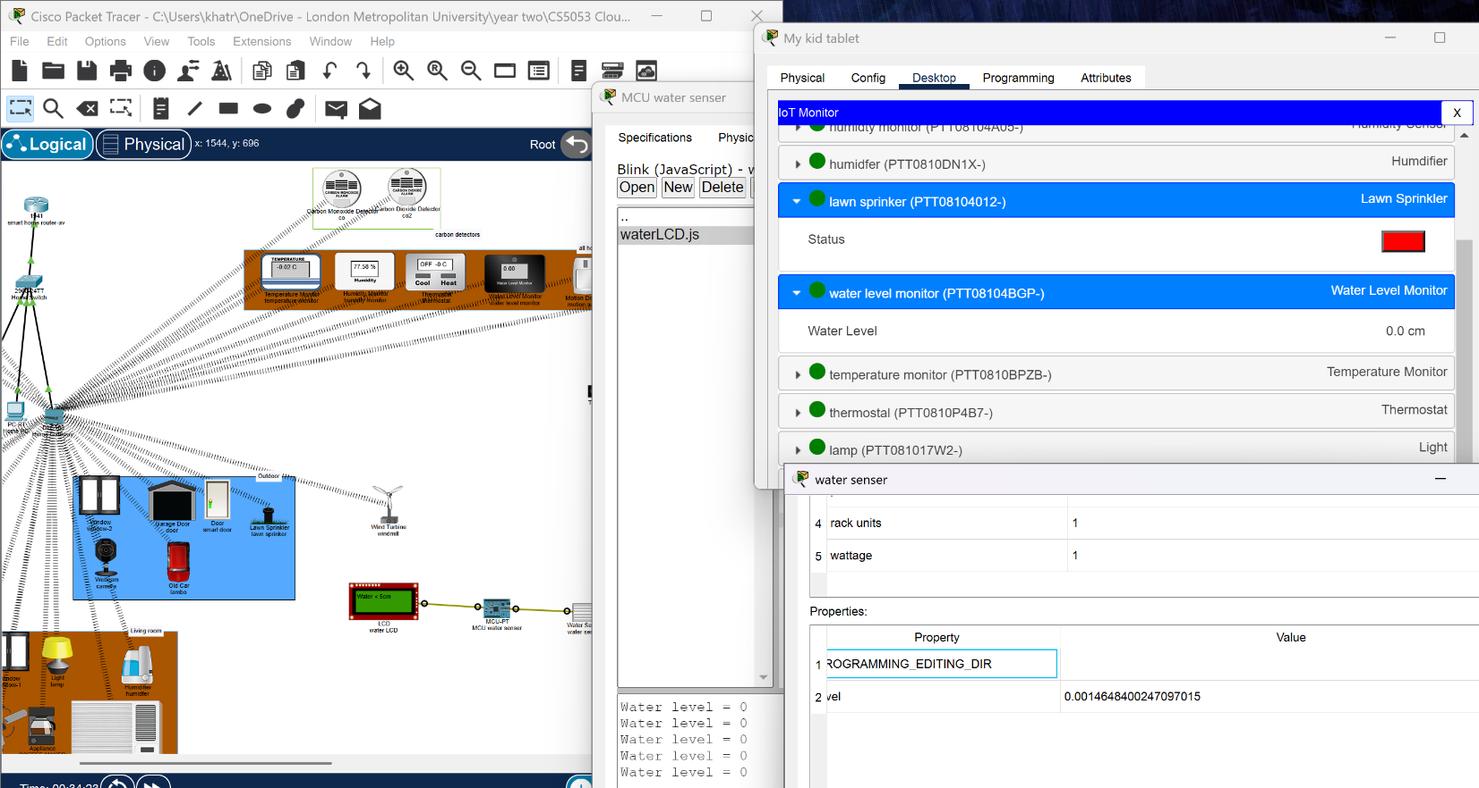

Fig 3.2.A. water for less than 5 cm via MCU and IoT condition system.

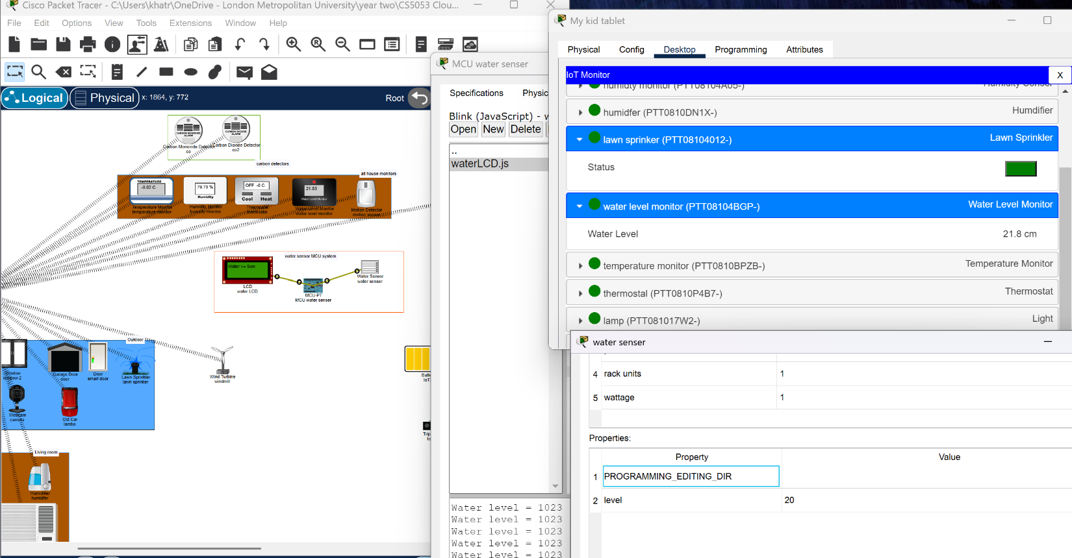

Fig 3.2.A. water for more than 5 cm via the MCU and IoT condition system.

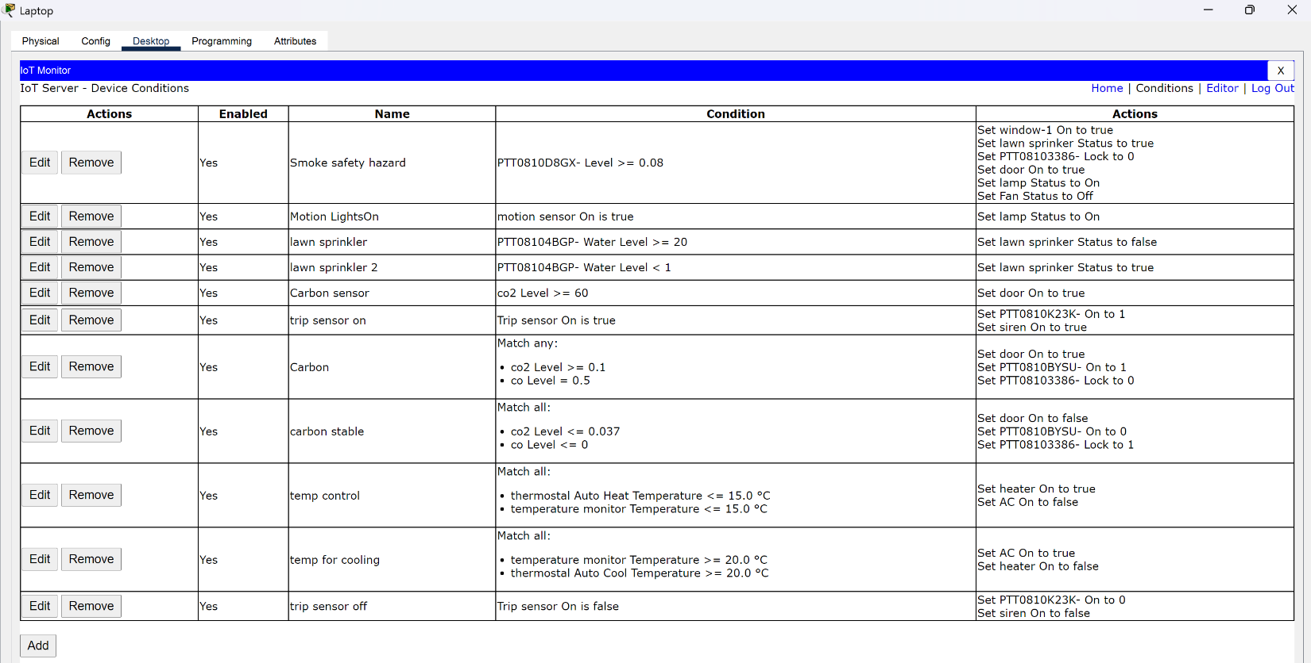

Fig 3.2.C. lawn sprinkler conditions

The lawn sprinkler auto-starts and stops while the LCDs display the text to the user.

## 3.3 Wind Turbine Energy Generation

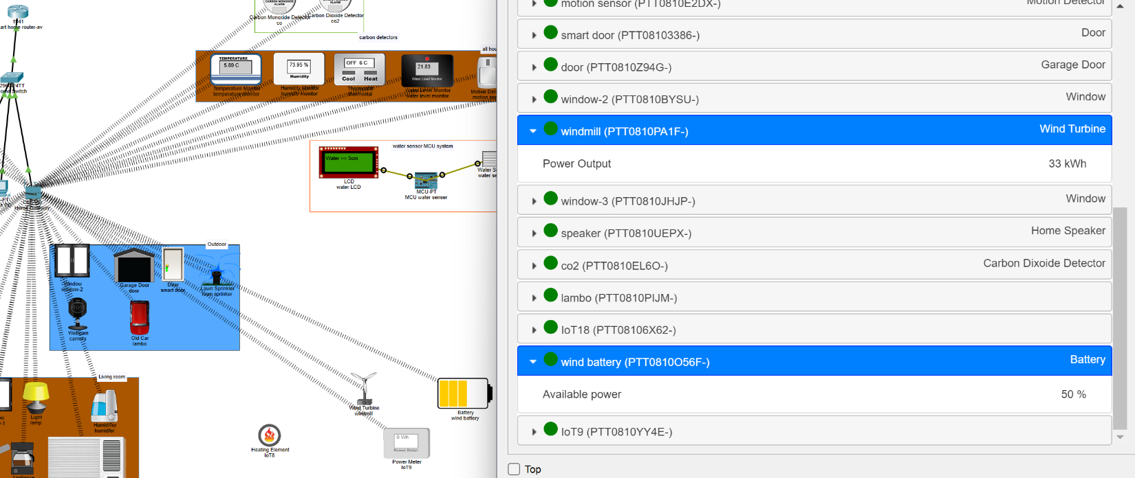

Fig 3.3.A. Setting up wind power setup via wireless

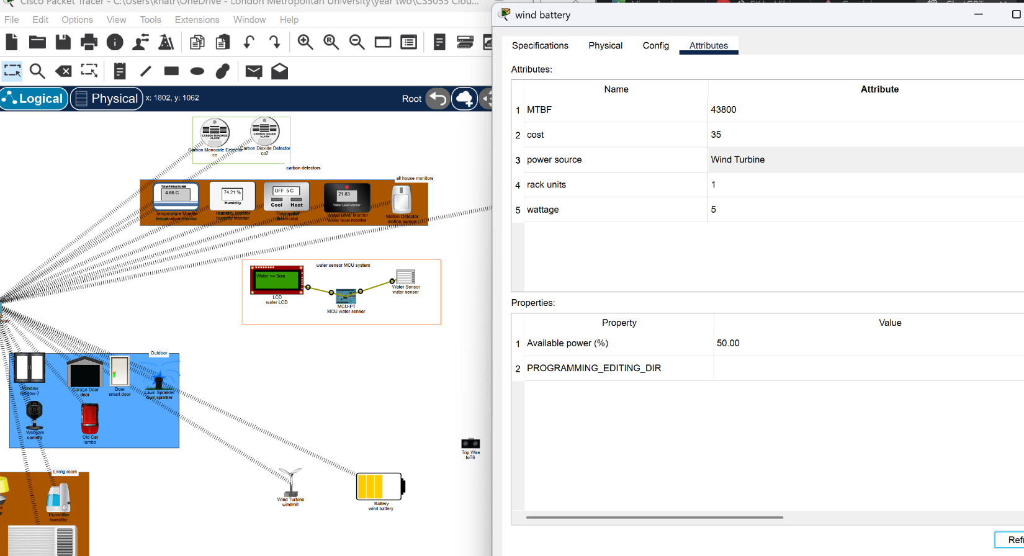

Fig 3.3.B. setting battery source

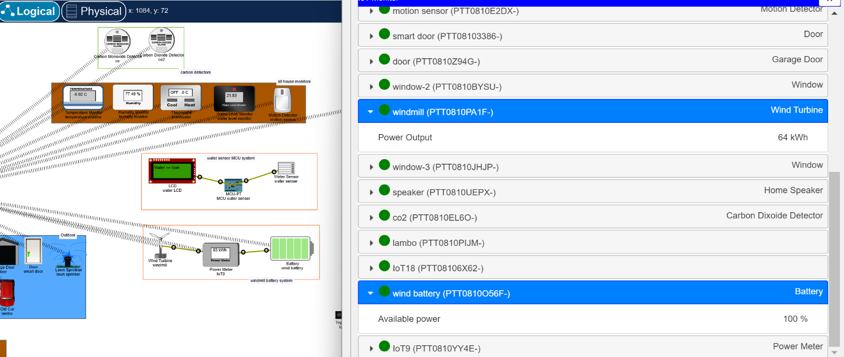

Fig 3.3.C. battery fully charged through the windmill with a wire and wireless for live monitoring.

## 3.4 CO Threshold Detection and Garage Automation

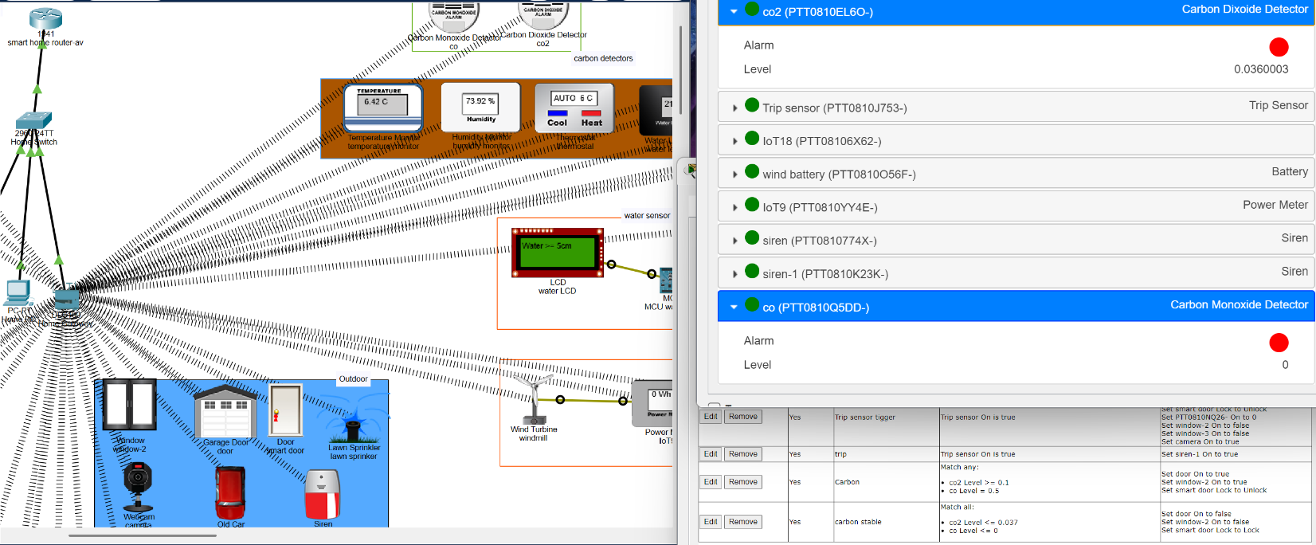

Fig 3.4.A. While there is no car, smoke the door along with live stats and conditions.

The condition relies on the sensor, and when the set level of the smoke is crossed, the door automatically opens for open air.

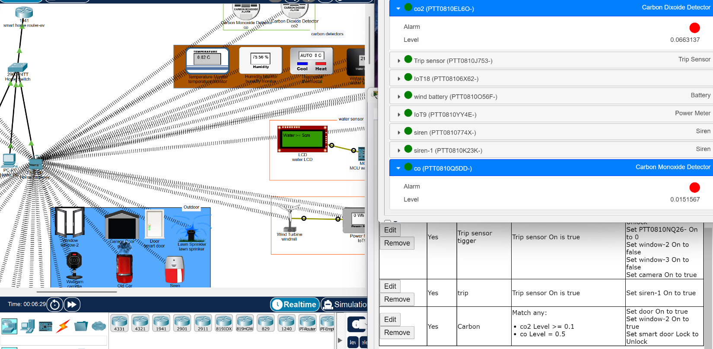Fig 3.4.B. While there is car smoke with extreme pollution, and a response to the condition, doors, windows, etc, are open.

Fig 3.4.C. additional condition for user safety for real life.

## 3.5 Humidity Monitoring and Environmental Feedback

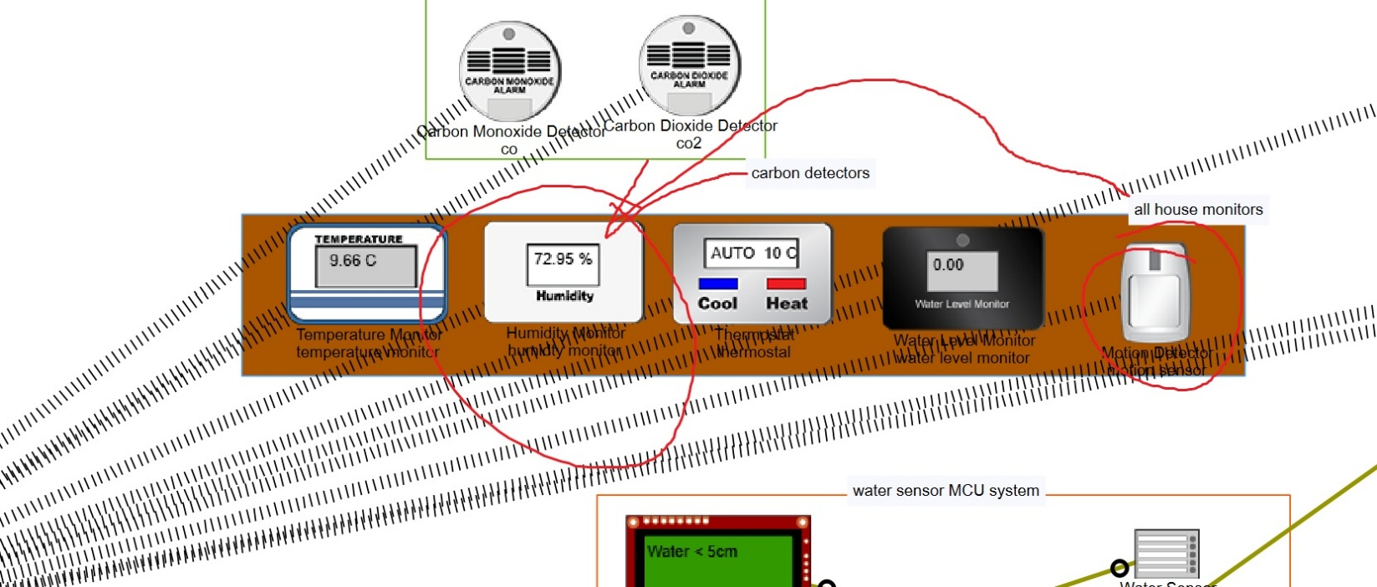

Fig 3.5.A. Live change of humidity monitoring while the humidifier is on/off and send back to the IoT devices controller via wireless network.

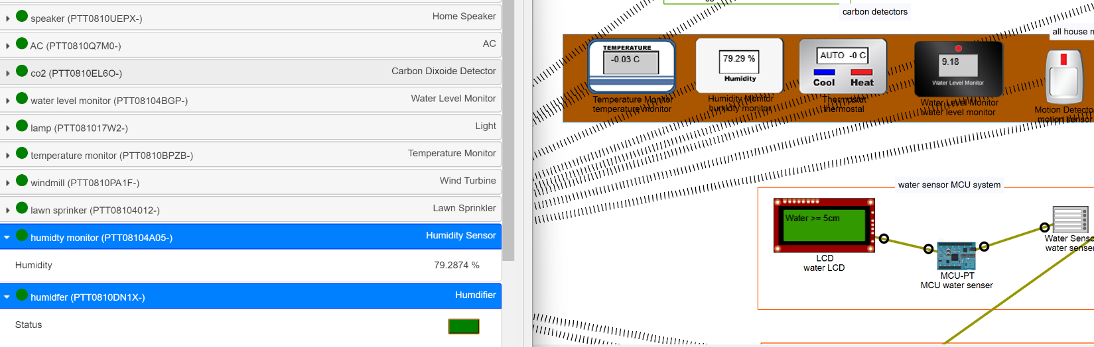

Fig 3.5.B. Live change of humidity monitoring while the humidifier is on/off and send back to the IoT devices controller via wireless network.

## 3.6 Trip Sensor and Security Response

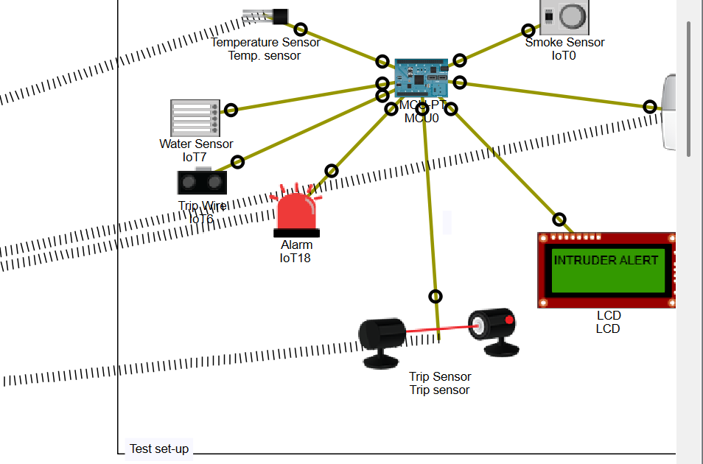

Fig 3.6.A. MCU and trip sensor test and trial with “Intruder alert”

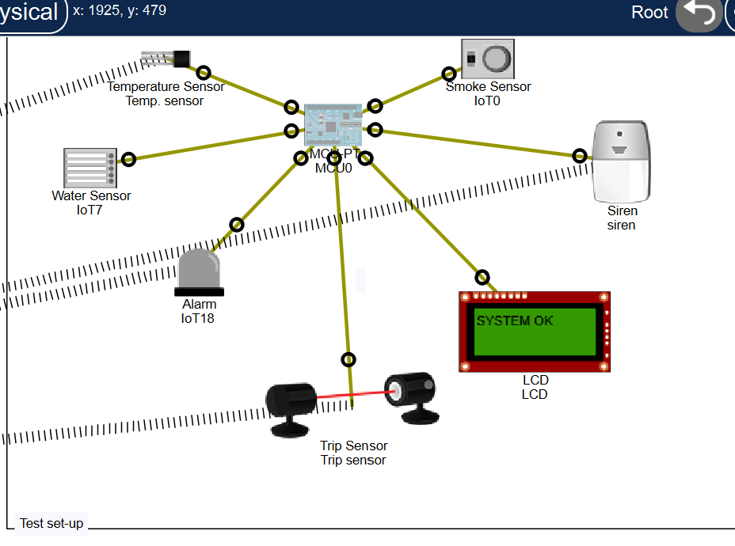

Fig 3.6.B. MCU and trip sensor test and trail with “system ok”

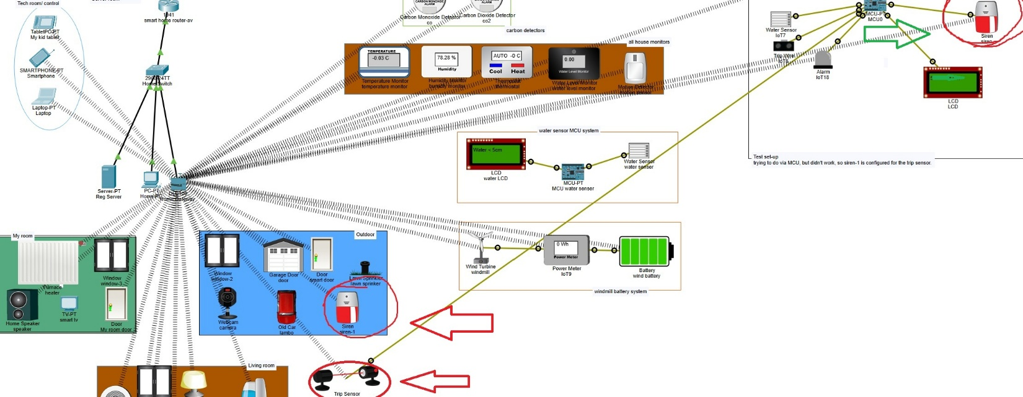 Fig 3.6.C. The trip sensor is triggered, and as a result, sirens are alerted.

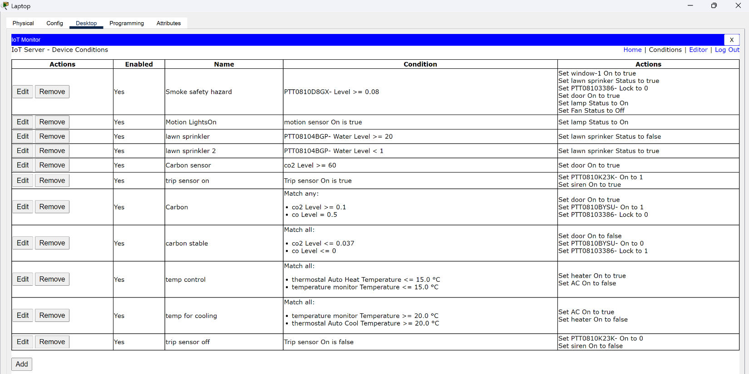  
Fig 3.6.D. Condition for when the sensor is triggered.

Fig 3.6.E. Condition for when the sensor is not triggered.



Fig 3.6.F. when the sensor is not triggered.

## 3.7 Thermostat Heating and Cooling Control

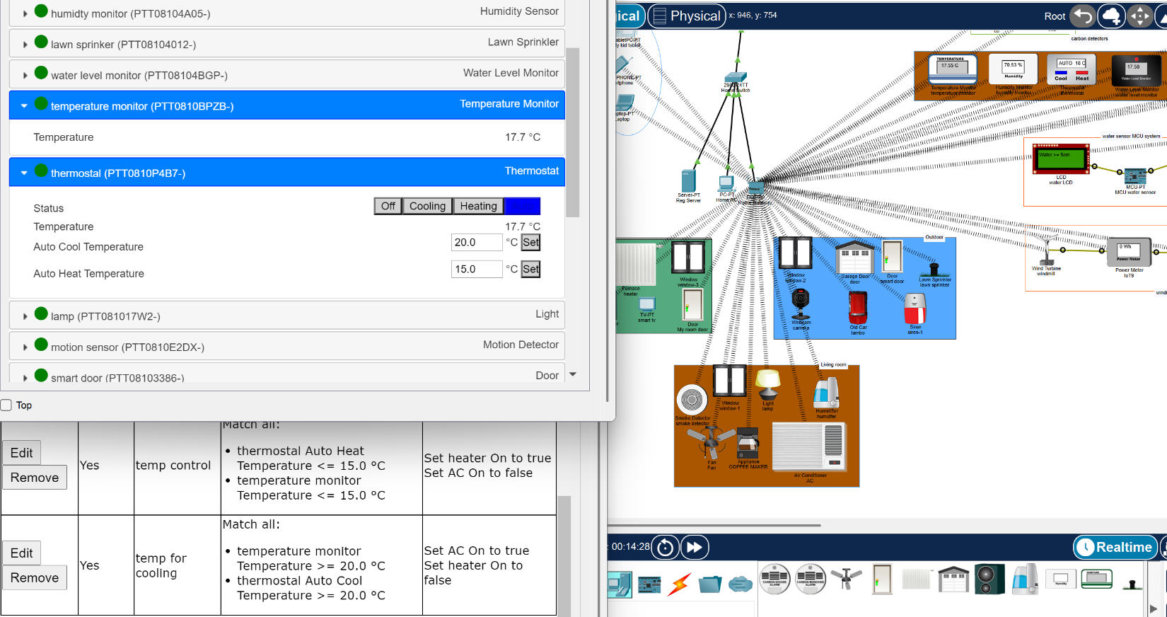

Fig 3.7. Condition for the heating and cooling as per the temperature read and the Auto setting thermostat too.

This system is auto, which means heating is on if the temperature goes below 15 degrees and stops when it reaches 20 degrees. Similarly, vice versa for the AC for cooling. This loop keeps the house with the user's needs.

# 4. Critical Reflection and things learned.

The simulation enhances the understanding of the IoT architecture, device embedded system design.

* I learned early that IoT devices must have unique names. Having the same name prevented registration, and having correct names helps in the real IoT systems.
* Login errors on phones and laptops were caused by incorrect IP addresses. Guidance from my tutor reinforced how sensitive IoT communication is.

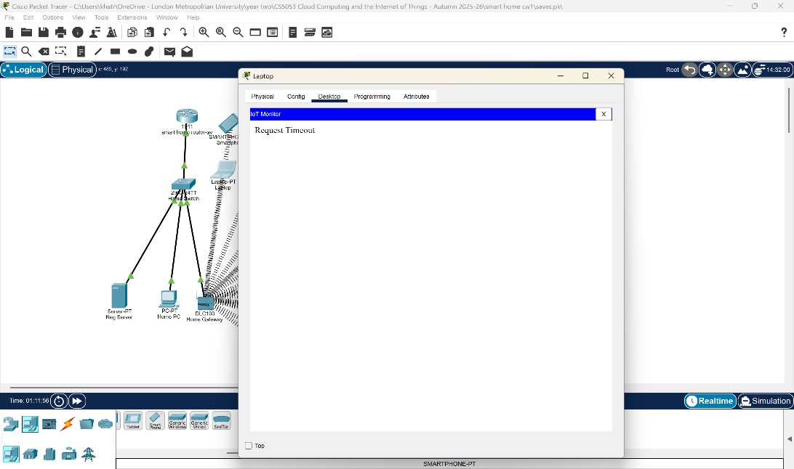

Fig 4.A. Message displayed when the IP address is wrong.

* Using the wrong port or cable type caused devices to fail. This strengthened my understanding of the physical layer and the wireless setting.
* Manual config of wireless helps me change the IoT devices, such as remote control, home server connection and DHCP/static to improve the connectivity.

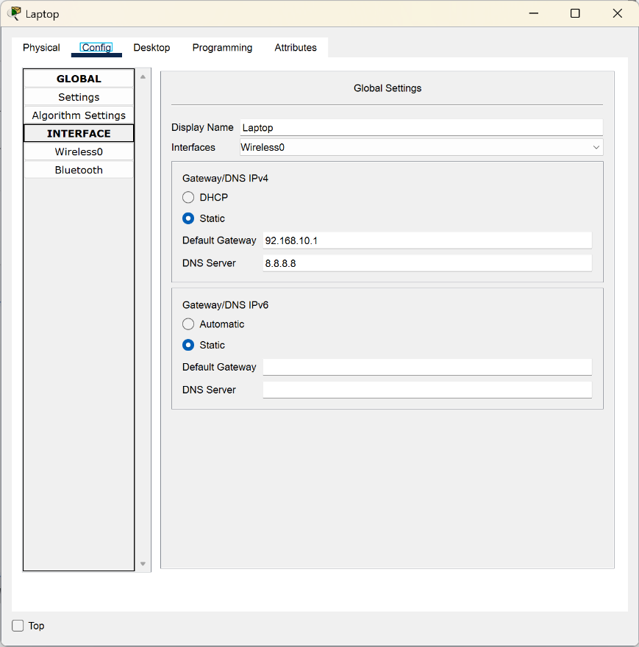

Fig 4.B. Manual config example.

* Some sensors in the real world lack/disable physical or wireless ports by default. This required me to add the digital or analogue pins through the advanced settings, or sometimes completely change the physical components (antennas) of the devices.

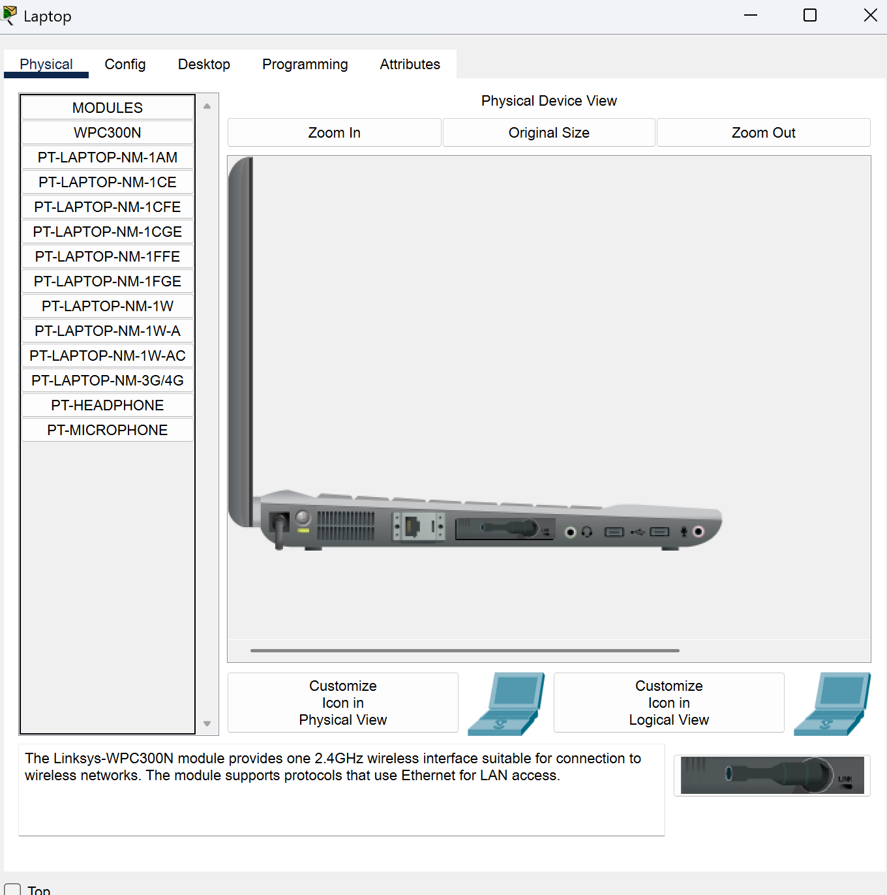

Fig. 4.C. Example of swapping the laptop compartment to make it wireless compatible.

* Organising the smart home system and also the documentation helped me navigate efficiently.

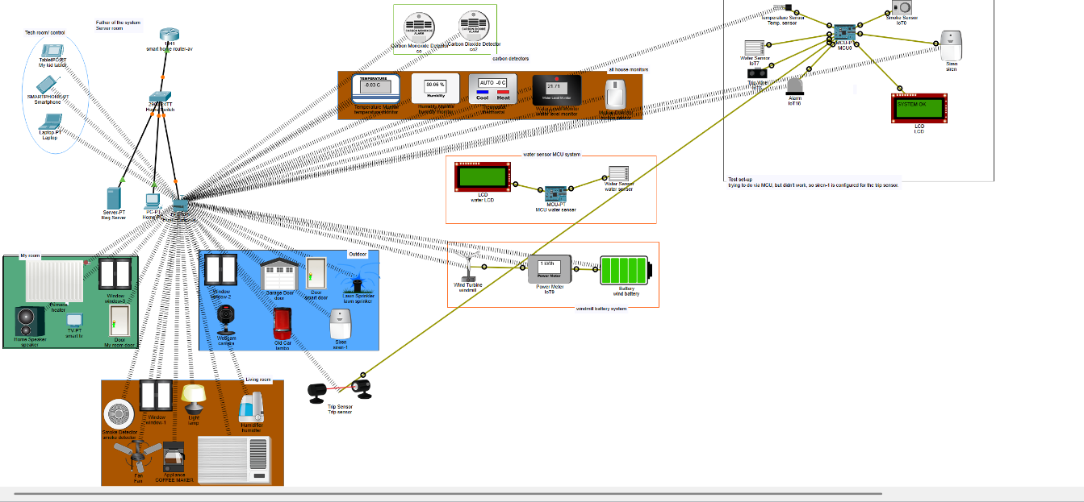

Fig. 4.D. Sample of an organised smart home system.

* Sticking to Packet Tracer **v.8.2.2.400** prevents compatibility issues.

Overall, some of these listed challenges taught me to catch disruptions and be careful when planning, testing, and iterative troubleshooting in Smart Home design.

# 5. Conclusion and Social Impact

The Smart Home simulation fulfilled all technical tasks, capable of automation, sensing, MCU control with wire and remote device control. This project shows not only mature theory but also the technical part of the module. The work developed practical IoT engineering proficiency and aligned comprehensively with module learning objectives.

Smart Homes enhance safety, energy efficiency, assisted living, and daily convenience (Chan et al., 2008). However, module lectures highlight risks such as data privacy, cybersecurity weaknesses, and vendor lock-in. Because Smart Homes collect highly detailed behavioral data, they are especially sensitive to misuse (Ziegeldorf et al., 2014). Effective Smart Home Design, therefore, requires balancing user benefits with strong security and ethical safeguards.

# 6. References

Atzori, L., Iera, A. and Morabito, G. (2010) ‘The Internet of Things: A survey’, *Computer Networks*, 54(15), pp. 2787–2805. Available at: <https://doi.org/10.1016/j.comnet.2010.05.010> (Accessed: 1 December 2025).

Buyya, R. and Dastjerdi, A.V. (eds.) (2016) *Internet of Things: Principles and Paradigms*. Cambridge, MA: Morgan Kaufmann. Available at: <https://www.sciencedirect.com/book/edited-volume/9780128053959/internet-of-things> (Accessed: 9 December 2025).

Chan, M., Estève, D., Escriba, C. and Campo, E. (2008) ‘A review of smart homes—Present state and future challenges’, *Computer Methods and Programs in Biomedicine*, 91(1), pp. 55–81. Available at: <https://doi.org/10.1016/j.cmpb.2008.02.001> (Accessed: 9 December 2025).

Cisco (2023) *Packet Tracer Help and Tutorials* [Computer program]. Cisco Networking Academy. Available at: <https://www.netacad.com> (Accessed: 10 November 2025).

Gubbi, J., Buyya, R., Marusic, S. and Palaniswami, M. (2013) ‘Internet of Things (IoT): A vision, architectural elements, and future directions’, *Future Generation Computer Systems*, 29(7), pp. 1645–1660.

<https://www.sciencedirect.com/science/article/abs/pii/S0167739X13000241> (Accessed: 15 November 2025).

Sethi, P. and Sarangi, S.R. (2017) 'Internet of Things: architectures, protocols, and applications', *Journal of Electrical and Computer Engineering*, 2017, Article ID 9324035. Available at: <https://doi.org/10.1155/2017/9324035> (Accessed: 4 December 2025).

Xu, L.D., He, W. and Li, S. (2014) 'Internet of Things in industries: a survey', *IEEE Transactions on Industrial Informatics*, 10(4), pp. 2233–2243. Available at: <https://doi.org/10.1109/TII.2014.2300753> (Accessed: 5 December 2025).

Ziegeldorf, J.H., Morchon, O.G. and Wehrle, K. (2014) ‘Privacy in the Internet of Things: threats and challenges’, *Security and Communication Networks*, 7(12), pp. 2728–2742. Available at: <https://doi.org/10.1002/sec.795> (Accessed: 9 December 2025).

# 7.Appendix: Project Logbook



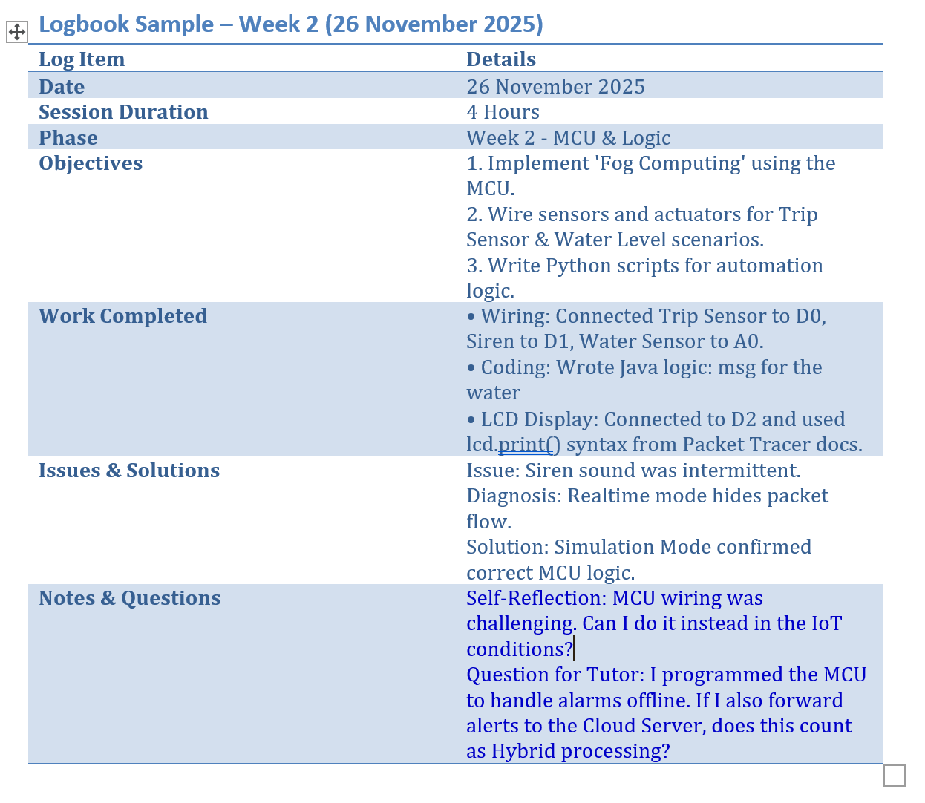

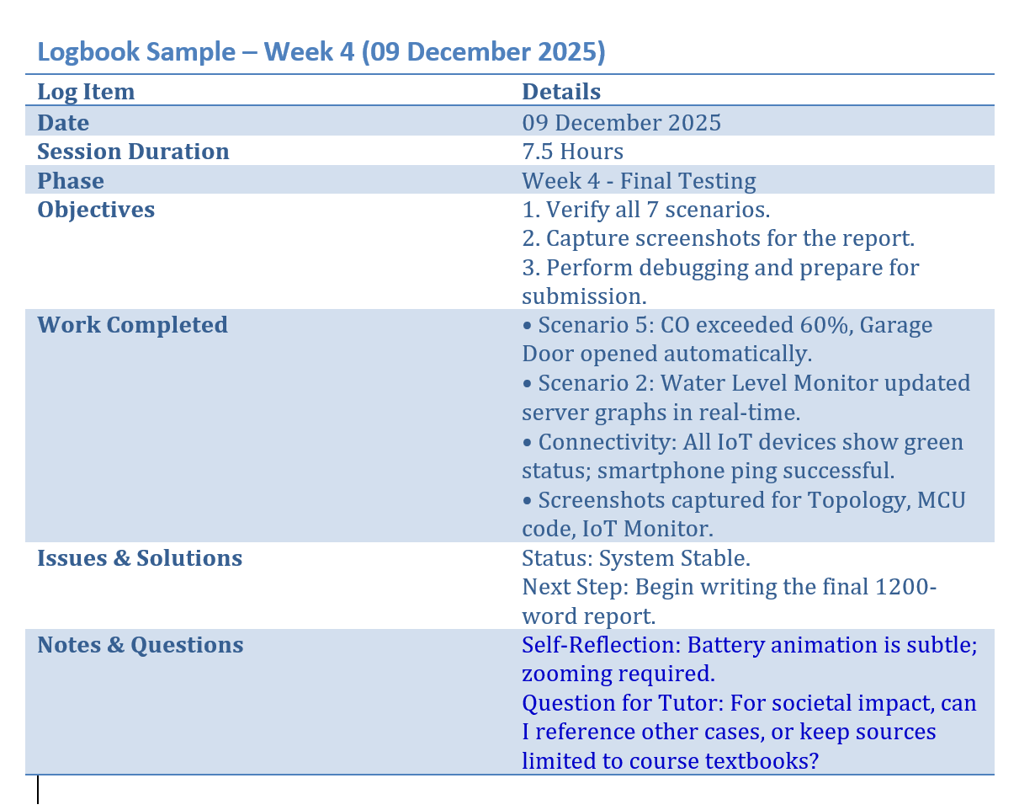

# 8. Github link

<https://github.com/aavash15/Cisco-Smart-Home-simulation>